Corrections 23.3.2015

# General

Cancel buttons does not work correctly, should go back to overview page.

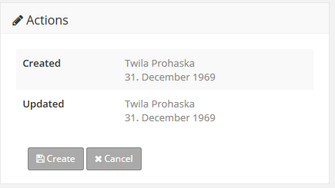

Wrong user is displayed, i am logged in with jaqeline.kuhn

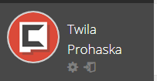

Wrong user is displayed, i am logged in with jaqueline.kuhn.

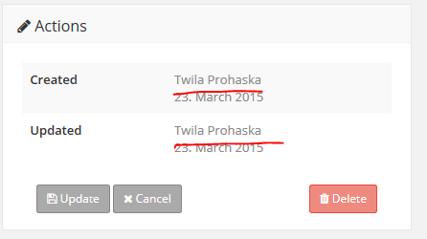

# Clients overview

Clients filter does not work.

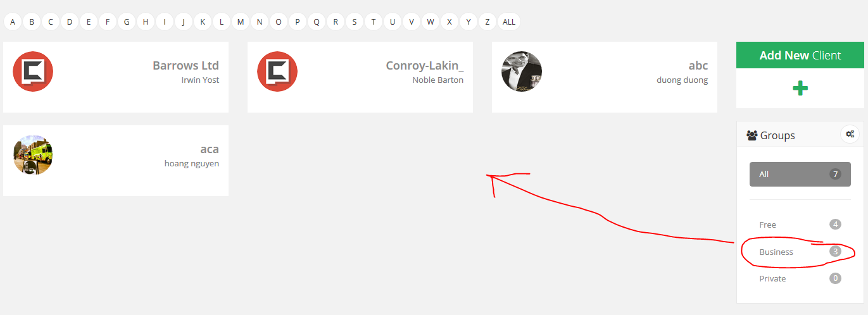

# Client edit

Add activity does not work proper.

* Reminder should not be required
* Date and Time fields are not correctly displayed  
  Check: http://panel.berginformatik.ch/panel_client_edit.php

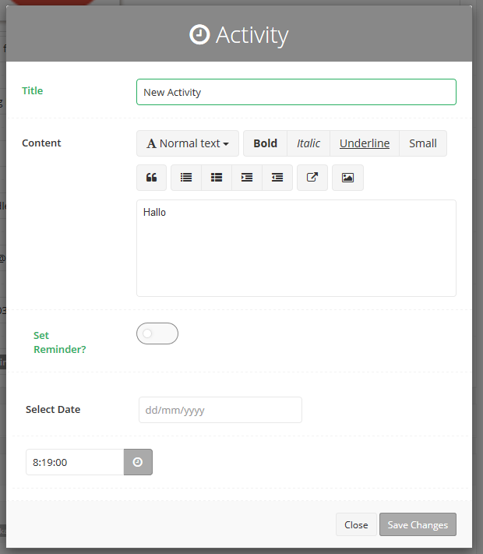

When add new activity, some irregular data is displayed.

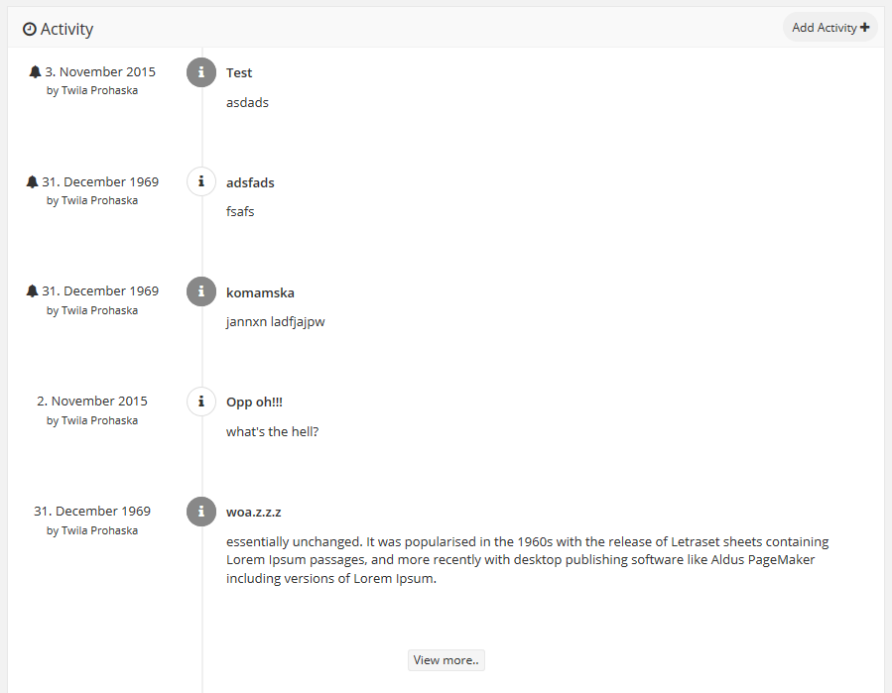

Add pagination or append data!!!

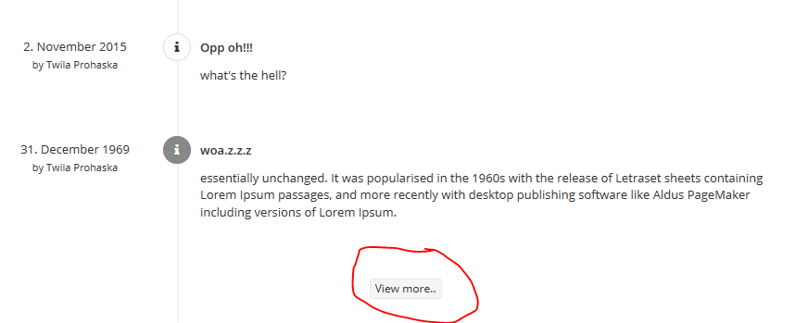

In the checklist widget, irregular data is displayed. I have not created any report!!!

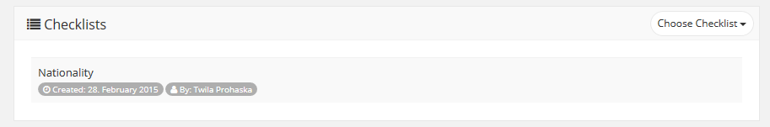

# Edit website

Notes widget shows wrong user: I am logged in with Jaqueline.kuhn

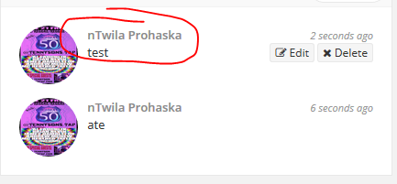

When I add new note, the view more button is displayed. But this button does not work!

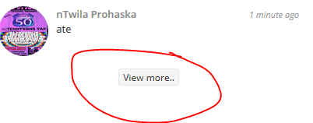

In the checklist widget, irregular data is displayed. I have not created any report!!!

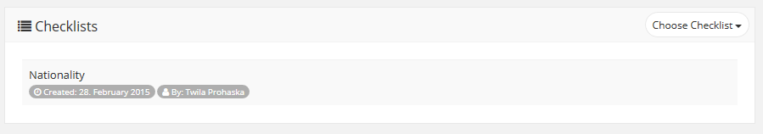

# Add checklist

Remove checklists widget.

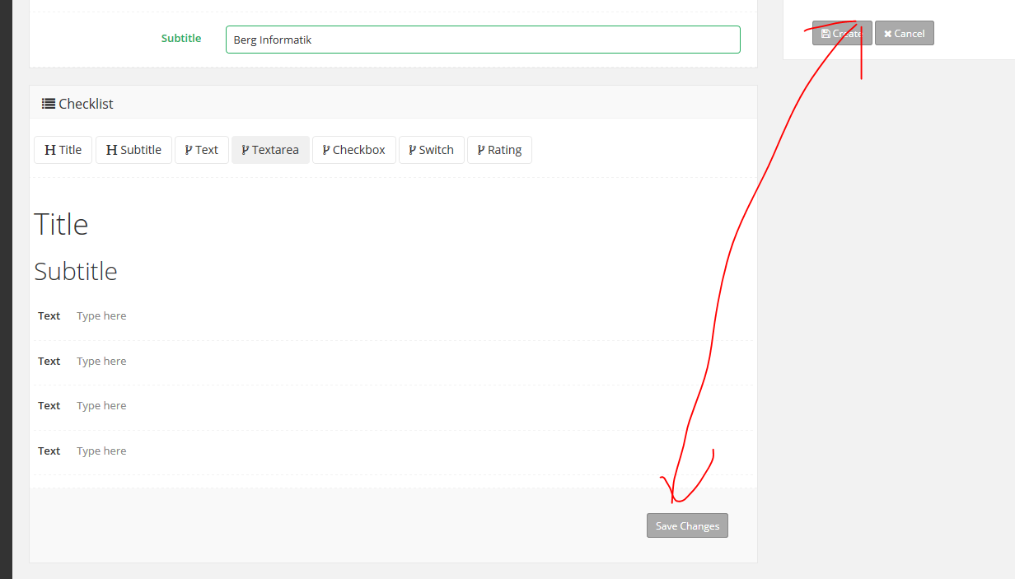

# Edit checklist

Can not edit schedules.

